Use Cases Description
UC2- Booking Room Management

For

Meeting Room
Booking System
(MRBS)

Prepared by K15T1-Team11
Van Lang University
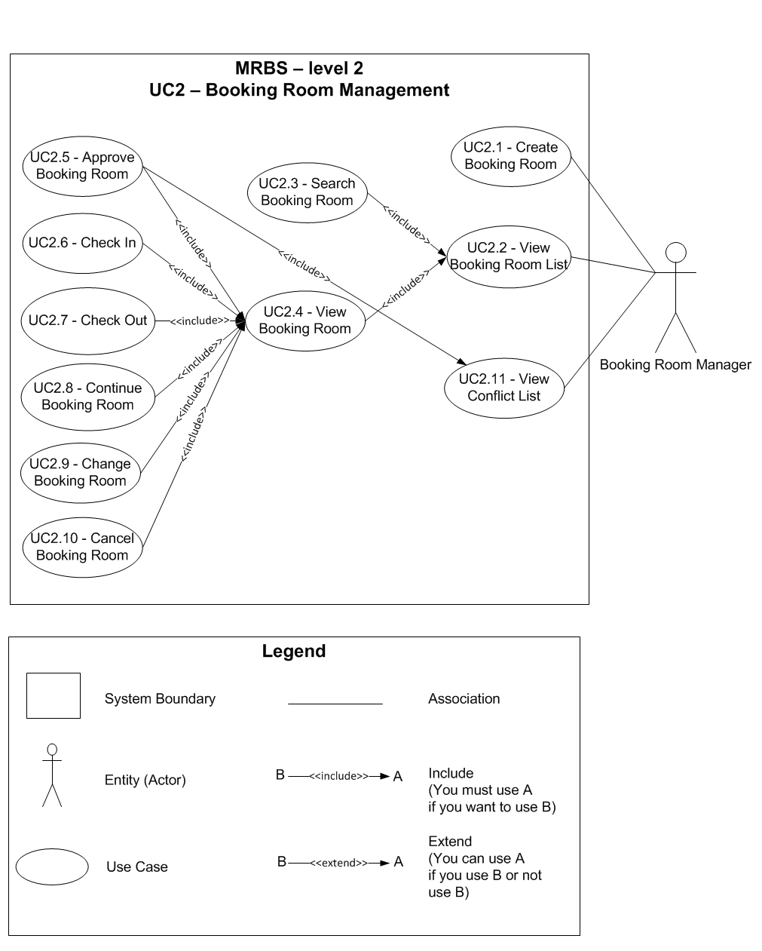

Table of Contents
UC2.1 – Create Booking Room 4
UC2.2 – View Booking Room List 5
UC2.3 – Search Booking Room 5
UC2.4 – View Booking Room 6
UC2.5 – Approve Booking Room 7
UC2.6 – Check In 8
UC2.7 – Check Out 9
UC2.8 – Continue Booking Room 9
UC2.9 – Change Booking Room 10
UC2.10 – Cancel Booking Room 11
UC2.11 – View Conflict List 12

UC2.1 – Create Booking Room
ID | UC2.1
Name | Create Booking Room
Author | Son Dang | Modify by | Tam Do
Date | 06/18/12 | Update | 07/20/12
Actor | Booking Room Manager
Description | User can create a new booking room
Precondition | User signed in system by Booking Room Manager’s account
Post condition: | System create a new booking room into database
Main flow: | 1. User press “Đặt phòng” button  2. System show a new dialog “Đặt phòng họp”  3. User fill in the form  4. User press “Đồng ý” button  5. System check the valid of information (BR2.1.01; BR2.1.02; BR2.1.03; BR2.1.04)  6. System check the valid of information with existing data in database (BR2.1.05)  7. System save a new booking room into database  8. System show message that “Đăng ký đặt phòng thành công”
Alternative flow: | After step 3 of main flow:  4. User press “Hủy” button  5. System turn off dialog “Đặt phòng họp”
Alternative flow: | After step 5 of main flow (BR2.1.01):  6. System show message that “Các thông tin đặt phòng không được để trống” with “OK” button
Alternative flow: | After step 5 of main flow (BR2.1.02; BR2.1.03; BR2.1.04):  6. System show message that “Thông tin nhập vào không hợp lệ” with “OK” button
Alternative flow: | After step 6 of main flow (BR2.1.05):  7. System show message that “Đơn đặt phòng này trùng giờ/địa điểm với đơn đặt phòng đã được duyệt, vui lòng thử lại” with “OK” button
Exception :
Includes:
Priority: | Very High
Business rules: | BR2.1.01 – Required field not accept null: borrower information; “Tên phòng”; “Giờ bắt đầu”; “Giờ kết thúc”  BR2.1.02 – “Giờ bắt đầu” not accept space between them; accept from “7:00” to “16:30” (except from “12:00” to “13:00”)  BR2.1.03 – “Giờ kết thúc” not accept space between them; accept from “7:30” to “17:00” (except from “12:00” to “13:00”)  BR2.1.04 – “Giờ kết thúc” must bigger than “Giờ bắt đầu” at least 30 minutes  BR2.1.05 – Had a booking that approved existing in system
Mockup screen

UC2.2 – View Booking Room List
ID | UC2.2
Name | View Booking Room List
Author | Tam Do | Modify by | Tam Do
Date | 07/04/12 | Update | 07/20/12
Actor | Booking Room Manager
Description | User can view a list of booking room for today
Precondition | User signed in system by Booking Room Manager’s account
Post condition: | System shows all booking room for a week
Main flow: | 1. User press “Trang chủ” tab  2. System show a list of booking room with the status “Chưa duyệt”
Alternative flow:
Exception :
Includes:
Priority: | Very High
Business rules:
Mockup screen

UC2.3 – Search Booking Room
ID | UC2.3
Name | Search Booking Room
Author | Son Dang | Modify by | Tam Do
Date | 06/18/12 | Update | 07/20/12
Actor | Booking Room Manager
Description | User can search booking room by room, status of booking
Precondition | User signed in system by Booking Room Manager’s account  User staying at “Trang chủ” form
Post condition: | System search the results
Main flow: | 1. User choose room that want to see  2. System show a timetable of this week for room that user choose
Alternative flow: | After step 2 of main flow:  3. User choose “>>” button (next week)  4. System show a timetable of next week for room that user choose
Alternative flow: | After step 4 of Alternate flow 1:  5. User choose “<<” button (previous week)  6. System show a timetable of next week for room that user choose
Alternative flow: | After step 2 of main flow (or step 4 of Alternate flow 1):  5. User choose “Tuần hiện tại” buuton (this week)  6. System show a timetable of this week for room that user choose
Alternative flow: | 1. User choose the status of booking room that want to see  2. System show a list of booking corresponding with the status of booking
Exception :
Includes:
Priority: | Very High
Business rules:
Mockup screen

UC2.4 – View Booking Room
ID | UC2.4
Name | View Booking Room
Author | Son Dang | Modify by | Tam Do
Date | 06/18/12 | Update | 07/20/12
Actor | Booking Room Manager
Description | User can view one booking room that has not checked out
Precondition | User signed in system by Booking Room Manager’s account  User staying at “Trang chủ” form  User searching a list of booking room that want to view by the status of booking
Post condition: | System view a detail booking room
Main flow: | 1. User double click into booking room that want to view  2. System show new dialog “Thông tin đặt phòng”  3. System check the status of booking (BR2.4.01)  4. System show a form booking room corresponding with the status of booking that user choose
Alternative flow:
Exception :
Includes:
Priority: | High
Business rules: | BR2.4.01 – Must show a form corresponding with the status of booking  + Status “Đang dùng” – Form “Trả phòng”  + Status “Đã duyệt” – Form “Nhận phòng”  + Status “Chưa duyệt” – Form “Duyệt phòng”
Mockup screen

UC2.5 – Approve Booking Room
ID | UC2.5
Name | Approve Booking Room
Author | Tam Do | Modify by | Tam Do
Date | 07/12/12 | Update | 07/20/12
Actor | Booking Room Manager
Description | User can approve a booking room
Precondition | User signed in system by Booking Room Manager’s account  User staying at “Trang chủ” form  User creating or viewing a booking room or viewing a list of conflict
Post condition: | System change the status of this booking room to “Đã duyệt”  System reject the others booking room
Main flow: | 1. User check “Duyệt” radio button  2. User press “Đồng ý” button  3. System check the valid of information with existing data in database (BR2.5.01)  4. System save into database
Alternative flow: | After step 3 of main flow (BR2.5.01):  4. System show message that “Đơn đặt phòng này trùng giờ/địa điểm với đơn đặt phòng đã được duyệt, vui lòng thử lại” with “OK” button
Exception :
Includes:
Priority: | Very High
Business rules: | BR2.5.01 – Had a booking that approved existing in system
Mockup screen

UC2.6 – Check In
ID | UC2.6
Name | Check In
Author | Son Dang | Modify by | Tam Do
Date | 06/18/12 | Update | 07/20/12
Actor | Booking Room Manager
Description | User can check in one booking room that has approved booking
Precondition | User signed in system by Booking Room Manager’s account  User staying at “Trang chủ” form  User viewing a booking room with the status is “Đã duyệt”
Post condition: | System check in booking room and save into database
Main flow: | 1. User press “Nhận” button next to information of borrower “Người mượn tiếp theo”  2. System show message that “Ghi nhận người mượn nhận phòng lúc hh:mm, Bạn có chắc người này nhận phòng chứ” with “Yes” and “No” button  3. User press “Yes” button  4. System check in this booking and save into database  5. System change the current status of booking
Alternative flow: | After step 2 of main flow:  3. User press “No” button  4. Nothing appear in form
Exception :
Includes:
Priority: | Very High
Business rules:
Mockup screen

UC2.7 – Check Out
ID | UC2.7
Name | Check Out
Author | Son Dang | Modify by | Tam Do
Date | 06/18/12 | Update | 07/20/12
Actor | Booking Room Manager
Description | User can check out one booking room that has checked in
Precondition | User signed in system by Booking Room Manager’s account  User staying at “Trang chủ” form  User viewing a booking room with the status is “Đang dùng”
Post condition: | System check out booking room and save into database
Main flow: | 1. User press “Đồng ý”  2. System check out this booking and save into database  3. System change the current status of booking
Alternative flow: | 1. User press “Hủy”  2. System turn off this form
Exception :
Includes:
Priority: | Very High
Business rules:
Mockup screen

UC2.8 – Continue Booking Room
ID | UC2.8
Name | Continue Booking Room
Author | Tam Do | Modify by | Tam Do
Date | 07/12/12 | Update | 07/20/12
Actor | Booking Room Manager
Description | User can continue to booking room that has checked in
Precondition | User signed in system by Booking Room Manager’s account  User staying at “Trang chủ” form  User viewing a booking room with the status is “Đang dùng”
Post condition: | System save new information about this booking into database
Main flow: | 1. User choose “Mượn tiếp” button  2. User fill in the form  3. User press “Đồng ý” button  4. System check the valid of information (BR2.8.01; BR2.8.02; BR2.8.03)  5. System check the valid of information with existing data in database (BR2.8.04)  6. System save into database
Alternative flow: | After step 2 of main flow:  3. User press “Hủy” button  4. System restore all information before user input
Alternative flow: | After step 4 of main flow (BR2.8.01):  5. System show message that “Không được để trống thông tin thời gian muốn mượn tiếp” with “OK” button
Alternative flow: | After step 4 of main flow (BR2.8.02, BR2.8.03):  5. System show message that “Thông tin nhập vào không hợp lệ” with “OK” button
Alternative flow: | After step 5 of main flow (BR2.8.04):  6. System show message that “Đơn đặt phòng này trùng giờ/địa điểm với đơn đặt phòng đã được duyệt, vui lòng thử lại” with “OK” button
Exception :
Includes:
Priority: | Low
Business rules: | BR2.8.01 – Required field not accept null: “Thời gian mượn tiếp đến”;  BR2.8.02 – “Thời gian mượn tiếp đến” not accept space between them; accept from “7:30” to “17:00” (except from “12:00” to “13:00”)  BR2.8.03 – “Thời gian mượn tiếp đến” must bigger than “Thời gian trả” at least 30 minutes  BR2.8.04 – Had a booking that approved existing in system
Mockup screen

UC2.9 – Change Booking Room
ID | UC2.9
Name | Change Booking Room
Author | Son Dang | Modify by | Tam Do
Date | 06/18/12 | Update | 07/20/12
Actor | Booking Room Manager
Description | User can change one booking room that has not checked in
Precondition | User signed in system by Booking Room Manager’s account  User staying at “Trang chủ” form  User viewing a detail booking room with the status is “Đã duyệt” or “Chưa duyệt”
Post condition: | System change a booking room and save into database
Main flow: | 1. User press “Đổi phòng” button  2. System show message that “Bạn muốn đổi thông tin đặt phòng này?” with “Yes” and “No” button  3. User press “Yes” button  4. User edit a booking room information that accept to edit  5. User press “Đồng ý” button  6. System check the valid of information (BR2.9.01; BR2.9.02; BR2.9.03; BR2.9.04)  7. System check the valid of information with existing data in database (BR2.9.05)  8. System save a booking room information that edited in database  9. System show message that “Thay đổi thông tin đặt phòng thành công” with “OK” button
Alternative flow: | After step 2 of main flow:  3. User press “No” button  4. Nothing appear
Alternative flow: | After step 4 of main flow:  5. User press “Hủy” button  6. System restore all information before user edit
Alternative flow: | After step 6 of main flow (BR2.9.01):  7. System show message that “Không được để trống thông tin đặt phòng” with “OK” button
Alternative flow: | After step 6 of main flow (BR2.9.02, BR2.9.03, BR2.9.04):  7. System show message that “Thông tin nhập vào không hợp lệ” with “OK” button
Alternative flow: | After step 7 of main flow (BR2.9.05):  8. System show message that “Đơn đặt phòng này trùng giờ/địa điểm với đơn đặt phòng đã được duyệt, vui lòng thử lại” with “OK” button
Exception :
Includes:
Priority: | Normal
Business rules: | BR2.9.01 – Required field not accept null: “Tên phòng”; “Ngày sử dụng”; “Thờig ian bắt đầu”; “Thời gian kết thúc”  BR2.9.02 – “Thời gian bắt đầu” not accept space between them; accept from “7:00” to “16:30” (except from “12:00” to “13:00”)  BR2.9.03 – “Thời gian kết thúc” not accept space between them; accept from “7:30” to “17:00” (except from “12:00” to “13:00”)  BR2.9.04 – “Thời gian kết thúc” must bigger than “Thời gian bắt đầu” at least 30 minutes  BR2.9.05 – Had a booking that approved existing in system
Mockup screen

UC2.10 – Cancel Booking Room
ID | UC2.10
Name | Cancel Booking Room
Author | Son Dang | Modify by | Tam Do
Date | 06/18/12 | Update | 07/04/12
Actor | Booking Room Manager
Description | User can cancel one booking room that has not checked in
Precondition | User signed in system by Booking Room Manager’s account  User staying at “Trang chủ” form  User viewing a detail booking room with the status is “Đã duyệt” or “Chưa duyệt”
Post condition: | System cancel a booking room and save into database
Main flow: | 1. User press “Hủy phòng” button  2. System show message that “Bạn muốn hủy thông tin đặt phòng này?” with “Yes” and “No” button  3. User press “Yes” button  4. System cancel this booking and save into database  5. System turn off dialog “Thông tin đặt phòng”
Alternative flow: | After step 2 of main flow:  3. User press “No” button  4. Nothing appear
Exception :
Includes:
Priority: | Normal
Business rules:
Mockup screen

UC2.11 – View Conflict List
ID | UC2.11
Name | View Conflict List
Author | Tam Do | Modify by
Date | 07/03/12 | Update
Actor | Booking Room Manager
Description | User can view a list of conflict booking room
Precondition | User signed in system by Booking Room Manager’s account
Post condition: | System shows all conflict by room
Main flow: | 1. User press “Danh sách xung đột”  2. System show “Danh sách xung đột” tab  3. System show a list of conflict  4. User choose a conflict  5. System show a list of conflict booking of that conflict
Alternative flow:
Exception :
Includes:
Priority: | Normal
Business rules:
Mockup screen

